**C++ PROJECT FILE**

**GAMING WEBSITE**

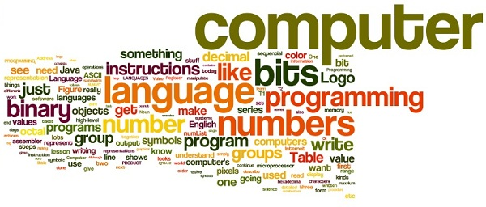



**Name : ANIRUDH SHARMA**

**Class : XII-C**

**Roll No.:**

**School : FATHER AGNEL SCHOOL**

INDEX

1. Certificate
2. Acknowledgement
3. Introduction to Project
4. Hardware and Software Requirements
5. Classes Used
6. Source Code
7. Output Screens
8. Bibliography

**CERTIFICATE**

# This is to certify that Anirudh Sharma of class XII-C has completed the project

# “Gaming Website”

during the session 2015-16 under my guidance and supervision .

**Mrs. Kamaljeet Kaur**

**Computer Science Dept.**

# I would like to express my heartfelt gratitude towards my Computer Science teacher, Ma’am Kamaljeet Kaur, without whose expert advice, unwavering encouragement, and infinite patience, this project would have been impossible to execute.

**ACKNOWLEDGEMENT**

**INTRODUCTION**

This game is remarkable example of how C++ can be used to create games which are fun and easy to play and can also aid as teaching tool to arouse interest among students as well deliver important concepts that are crucial in coding and thus enhance the overall coding experience.

Simple concepts and logical thinking have been employed to create movement to mimic the movement of snake in the game ”The Snake” and an algorithm was created to create a player versus computer feel in the game “Tic Tac Toe”.

The controls are simple and easy to understand. For beginners a help screen has been provided.

The controls are as follows:

* **SNAKE**
* Movement:-
* W to move snake up
* A to move snake left
* S to move snake down
* D to move snake right
* With each food that the snake eats ,its length increases
* After 4 foods have been eaten the speed of the snake increases and                 the computer randomly generates obstacles which the snake has to avoid. Movement along the walls is allowed.
* If the  snake goes into the left boundary it emerges out from right and vice-versa and same for the upper and bottom boundaries.
* A player may lose the game, if he or she may touch the randomly generated obstacles or the snake eats itself
* **TIC TAC TOE**
* Template is provided to user to enter 0 or x in the desired position by entering the respective no. In the template position the computer automatically places 0 or x according to the player's turn.
* If three consecutive 0 or x either vertically or horizontally or diagonally occurs then the respective player wins.
* If no such condition mentioned above occurs and all the places are filled the match is a draw.

**PREQUISITES**

* **ACCOUNT REGISTRY**
* Prior to playing the games player has to make an account in order to play the above games.
* He has to fill his valid details in the sign up form.
* Once the account has been successfully created the user is directed to the sign in page where the user enters his/her username and password.
* After the user has successfully signed in he/she gets two choices -
  + - 1 to play snake
    - 2 to play tic tac toe
    - 0 to log out and exit

With further improvements the program can be converted into full fledged gaming platform that can be used for commercial purpose.

**HARDWARE AND SOFTWARE REQUIREMENTS**

HARDWARE

RAM Requirement : 512 MB ( 53,68,70,912 bytes)

Size on Hard Disk : 22.0 KB (22,528 bytes)

Monitor Resolution : 1366 X 768

SOFTWARE

Operating System Used : Windows 7 Home Basic

Compiler : Turbo C++

**19 void game_start()**

**20 void instruction()**

**21 void snake()**

**22 void sign_up()**

**23 void sign_in()**

**1**

**2**

**3**

**4**

**5**

**6**

**7**

**8**

**9**

**10**

**11**

**12**

**13**

**14**

**15**

**16**

**17**

**18**

**20**

**void game_choose()**

**char all_places_fill(game)**

**char is_pos_repeate(int,game)**

**game position_teller(int)**

**char result(game &)**

**void multiplayer()**

**void tictactoe_menu()**

**void tictactoe()**

**char coordinate_check(hss [], coordinate [],int,int)**

**int level_gen(coordinate,int &)**

**coordinate food_gen(hss [],coordinate [],**

**coordinate &,int &)**

**void chk_food_eaten(hss [],coordinate [],**

**coordinate &,int &,int &,int &)**

**char up(hss [] ,coordinate [],int &, coordinate &,int &, int &)**

**char left(hss [] ,coordinate [],int &, coordinate &,int &, int &)**

**char down(hss [] ,coordinate [],int &, coordinate &,int &, int &)**

**char right(hss [] ,coordinate [],int &, coordinate &,int &, int &)**

**void game_over()**

**void score(hss [])**

**void snake_menu()**

**FUNCTIONS USED**

**CLASS USED**

**void game_choose()**

**char all_places_fill(game)**

**char is_pos_repeate(int,game)**

**game position_teller(int)**

**char result(game &)**

**void multiplayer()**

**void tictactoe_menu()**

**void tictactoe()**

**char coordinate_check(hss [], coordinate [],int,int)**

**int level_gen(coordinate,int &)**

**coordinate food_gen(hss [],coordinate [],**

**coordinate &,int &)**

**void chk_food_eaten(hss [],coordinate [],**

**coordinate &,int &,int &,int &)**

**STRUCTURES USED**

**void game_choose()**

**char all_places_fill(game)**

**char is_pos_repeate(int,game)**

**game position_teller(int)**

**char result(game &)**

**void multiplayer()**

**void tictactoe_menu()**

**void tictactoe()**

**char coordinate_check(hss [], coordinate [],int,int)**

**int level_gen(coordinate,int &)**

**coordinate food_gen(hss [],coordinate [],**

**coordinate &,int &)**

**void chk_food_eaten(hss [],coordinate [],**

**coordinate &,int &,int &,int &)**

SOURCE CODE

#include<fstream.h>

#include<conio.h>

#include<string.h>

#include<ctype.h>

#include<dos.h>

#include<iomanip.h>

#include<stdlib.h>

///////////////////////////////////////////////////////////////////////////////////////////////

//////////////////////////////////////TIC TAC TOE GAME/////////////////////////////////////////

///////////////////////////////////////////////////////////////////////////////////////////////

struct game

{

int pos[4];

char tictoe[10];

};

void snake();

void tictactoe();

void game_choose()

{

clrscr();

int i,j;

char ch='a'; //any value except 1,2,0

for(i=1,j=4;j<=25;j++)

{

gotoxy(i,j);

cout<<(char)186;

}

for(i=38,j=4;j<=25;j++)

{

gotoxy(i,j);

cout<<(char)186;

}

for(i=1,j=4;i<=38;i++)

{

gotoxy(i,j);

cout<<(char)205;

}

for(i=1,j=25;i<=38;i++)

{

gotoxy(i,j);

cout<<(char)205;

}

gotoxy(38,25);cout<<(char)188;

gotoxy(38,4);cout<<(char)187;

gotoxy(1,25);cout<<(char)200;

gotoxy(1,4);cout<<(char)201;

for(i=42,j=4;j<=25;j++)

{

gotoxy(i,j);

cout<<(char)186;

}

for(i=79,j=4;j<=25;j++)

{

gotoxy(i,j);

cout<<(char)186;

}

for(i=42,j=4;i<=79;i++)

{

gotoxy(i,j);

cout<<(char)205;

}

for(i=42,j=25;i<=79;i++)

{

gotoxy(i,j);

cout<<(char)205;

}

gotoxy(79,25);cout<<(char)188;

gotoxy(79,4);cout<<(char)187;

gotoxy(42,25);cout<<(char)200;

gotoxy(42,4);cout<<(char)201;

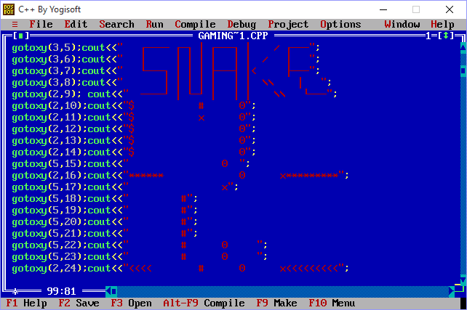

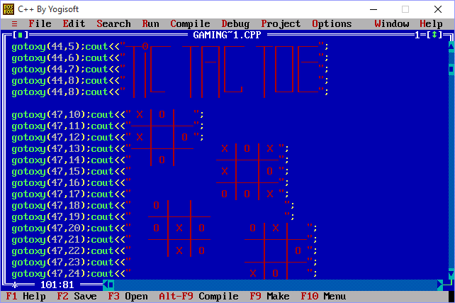

gotoxy(12,3);cout<<"1. RATTLE SNAKE";

gotoxy(55,3);cout<<"2. TIC TAC TOE";

gotoxy(74,1);cout<<"<0>EXIT";

while(ch!='1'&&ch!='2'&&ch!='0')

{

if(kbhit())

{

ch=getch();

}

}

if(ch=='1')

snake();

if(ch=='2')

tictactoe();

if(ch=='0')

exit(0);

getch();

}

char all_places_fill(game t)//checks if user has filled all the places of tictactoe

{

int i;

for(i=0;i<9;i++)

{

if(t.tictoe[i]=='1')

return('n');

}

return('y');

}

char is_pos_repeate(int op,game t)

{

if(t.tictoe[op-1]=='1')

return('n');

return('y');

}

game position_teller(int op)//returns the equivalent cursor position of int op(variable passed to it)

{

game position;

position.pos[1]=0;

if(op==1)

{

position.pos[0]=31;

position.pos[2]=10;

return(position);

}

if(op==2)

{

position.pos[0]=35;

position.pos[2]=10;

return(position);

}

if(op==3)

{

position.pos[0]=39;

position.pos[2]=10;

return(position);

}

if(op==4)

{

position.pos[0]=31;

position.pos[2]=12;

return(position);

}

if(op==5)

{

position.pos[0]=35;

position.pos[2]=12;

return(position);

}

if(op==6)

{

position.pos[0]=39;

position.pos[2]=12;

return(position);

}

if(op==7)

{

position.pos[0]=31;

position.pos[2]=14;

return(position);

}

if(op==8)

{

position.pos[0]=35;

position.pos[2]=14;

return(position);

}

if(op==9)

{

position.pos[0]=39;

position.pos[2]=14;

return(position);

}

position.pos[1]='-1';

return(position);

}

char result(game &t)//checks the result of the match

{

if(t.tictoe[0]=='o'&&t.tictoe[1]=='o'&&t.tictoe[2]=='o')

{

gotoxy(31,10);cout<<"O";

gotoxy(35,10);cout<<"O";

gotoxy(39,10);cout<<"O";

return ('o');

}

if(t.tictoe[3]=='o'&&t.tictoe[4]=='o'&&t.tictoe[5]=='o')

{

gotoxy(31,12);cout<<"O";

gotoxy(35,12);cout<<"O";

gotoxy(39,12);cout<<"O";

return ('o');

}

if(t.tictoe[6]=='o'&&t.tictoe[7]=='o'&&t.tictoe[8]=='o')

{

gotoxy(31,14);cout<<"O";

gotoxy(35,14);cout<<"O";

gotoxy(39,14);cout<<"O";

return ('o');

}

if(t.tictoe[0]=='o'&&t.tictoe[3]=='o'&&t.tictoe[6]=='o')

{

gotoxy(31,10);cout<<"O";

gotoxy(31,12);cout<<"O";

gotoxy(31,14);cout<<"O";

return ('o');

}

if(t.tictoe[1]=='o'&&t.tictoe[4]=='o'&&t.tictoe[7]=='o')

{

gotoxy(35,10);cout<<"O";

gotoxy(35,12);cout<<"O";

gotoxy(35,14);cout<<"O";

return ('o');

}

if(t.tictoe[2]=='o'&&t.tictoe[5]=='o'&&t.tictoe[8]=='o')

{

gotoxy(39,10);cout<<"O";

gotoxy(39,12);cout<<"O";

gotoxy(39,14);cout<<"O";

return ('o');

}

if(t.tictoe[0]=='o'&&t.tictoe[4]=='o'&&t.tictoe[8]=='o')

{

gotoxy(31,10);cout<<"O";

gotoxy(35,12);cout<<"O";

gotoxy(39,14);cout<<"O";

return ('o');

}

if(t.tictoe[2]=='o'&&t.tictoe[4]=='o'&&t.tictoe[6]=='o')

{

gotoxy(39,10);cout<<"O";

gotoxy(35,12);cout<<"O";

gotoxy(31,14);cout<<"O";

return ('o');

}

if(t.tictoe[0]=='x'&&t.tictoe[1]=='x'&&t.tictoe[2]=='x')

{

gotoxy(31,10);cout<<"X";

gotoxy(35,10);cout<<"X";

gotoxy(39,10);cout<<"X";

return ('x');

}

if(t.tictoe[3]=='x'&&t.tictoe[4]=='x'&&t.tictoe[5]=='x')

{

gotoxy(31,12);cout<<"X";

gotoxy(35,12);cout<<"X";

gotoxy(39,12);cout<<"X";

return ('x');

}

if(t.tictoe[6]=='x'&&t.tictoe[7]=='x'&&t.tictoe[8]=='x')

{

gotoxy(31,14);cout<<"X";

gotoxy(35,14);cout<<"X";

gotoxy(39,14);cout<<"X";

return ('x');

}

if(t.tictoe[0]=='x'&&t.tictoe[3]=='x'&&t.tictoe[6]=='x')

{

gotoxy(31,10);cout<<"X";

gotoxy(31,12);cout<<"X";

gotoxy(31,14);cout<<"X";

return ('x');

}

if(t.tictoe[1]=='x'&&t.tictoe[4]=='x'&&t.tictoe[7]=='x')

{

gotoxy(35,10);cout<<"X";

gotoxy(35,12);cout<<"X";

gotoxy(35,14);cout<<"X";

return ('x');

}

if(t.tictoe[2]=='x'&&t.tictoe[5]=='x'&&t.tictoe[8]=='x')

{

gotoxy(39,10);cout<<"X";

gotoxy(39,12);cout<<"X";

gotoxy(39,14);cout<<"X";

return ('x');

}

if(t.tictoe[0]=='x'&&t.tictoe[4]=='x'&&t.tictoe[8]=='x')

{

gotoxy(31,10);cout<<"X";

gotoxy(35,12);cout<<"X";

gotoxy(39,14);cout<<"X";

return ('x');

}

if(t.tictoe[2]=='x'&&t.tictoe[4]=='x'&&t.tictoe[6]=='x')

{

gotoxy(39,10);cout<<"X";

gotoxy(35,12);cout<<"X";

gotoxy(31,14);cout<<"X";

return ('x');

}

return ('d');

}

void multiplayer()

{

clrscr();

int i,sign,x,y,op;

char fill,choice,check,res,player1,player2;

game t,pos_right;

do

{

strcpy(t.tictoe,"111111111");

i=1;sign=1;

pos_right.pos[1]=0;

res='a';

clrscr();

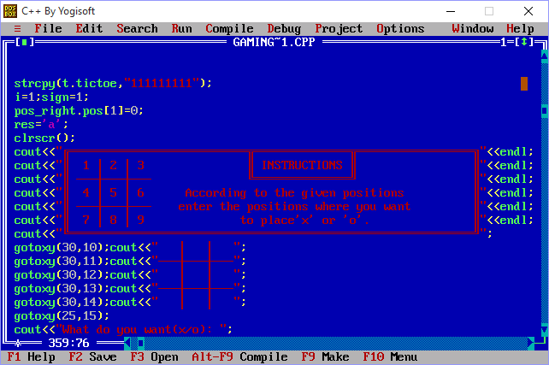

gotoxy(25,15);

cout<<"What do you want(x/o): ";

cin>>player1;

player1=tolower(player1);

if(player1!='o'&&player1!='x')

cout<<"\nWrong choice!";

else

{

if(player1=='o')

player2='x';

else

player2='o';

while(all_places_fill(t)!='y')

{

gotoxy(1,16);

if(sign==1)

cout<<"Enter the position("<<player1<<"'s turn)=";

if(sign==-1)

cout<<"Enter the position("<<player1<<"'s turn)=";

clreol();

cin>>op;

pos_right=position_teller(op);

if(pos_right.pos[1]=='-1')

{

cout<<"\nYou entered wrong position!";

getch();gotoxy(1,18);clreol();

}

else

{

check=is_pos_repeate(op,t);

if(check=='y')

{

cout<<"\nPosition is already occupied!";

getch();gotoxy(1,18);clreol();

continue;

}

x=pos_right.pos[0];

y=pos_right.pos[2];

gotoxy(x,y);

if(sign==1)

{

cout<<player1;

t.tictoe[op-1]=player1;

}

else

{

cout<<player2;

t.tictoe[op-1]=player2;

}

sign=sign*-1;

}

if(i>=5)

res=result(t);

if(res=='x'||res=='o')

break;

i++;

}

gotoxy(1,19);

if(res=='x')

cout<<"\t\t\t\t'X' WINS"<<endl;

if(res=='o')

cout<<"\t\t\t\t'O' WINS"<<endl;

if(res=='d')

cout<<"\t\t\t Match is DRAW"<<endl;

}//end of main else

cout<<"\n\t\t\t ONE MORE GAME ?(y/n): ";

cin>>choice;

}while(choice=='y'||choice=='Y');

}//end of game_start()

void tictactoe_menu()

{

clrscr();

int op,option;

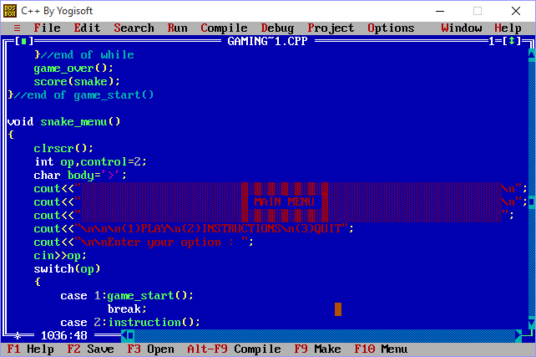

cout<<"\n\n\n(1)PLAY\n(2)INSTRUCTION\n(3)QUIT";

cout<<"\n\nEnter your option : ";

cin>>op;

switch(op)

{

case 1:multiplayer();

break;

case 2:clrscr();

cout<<"\n\n\n\n\n\n\n\n";

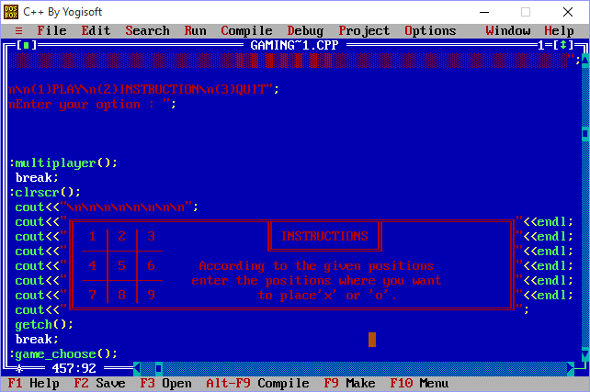

getch();

break;

case 3:game_choose();

break;

default:cout<<"\nYou entered wrong choice!";

}//end of switch()

tictactoe_menu();

}//end of menu()

void tictactoe()

{

clrscr();

int i,j;

cout<<" _______ _ ______ _______ _____ ______ _______ _____ ______ \n";

cout<<" |__ __|| || ____| |__ __|| _ || ____| |__ __|| _ || ____|\n";

cout<<" | | | || | | | | |_| || | | | | | | || |____ \n";

cout<<" | | | || | | | | _ || | | | | | | || ____|\n";

cout<<" | | | || |____ | | | | | || |____ | | | |_| || |____ \n";

cout<<" |_| |_||______| |_| |_| |_||______| |_| |_____||______|\n";

for(i=31,j=7;j<=25;j++)

{

gotoxy(i,j);

cout<<(char)220;

}

for(i=47,j=7;j<=25;j++)

{

gotoxy(i,j);

cout<<(char)220;

}

for(i=18,j=12;i<=60;i++)

{

gotoxy(i,j);

if(i%2==0)

cout<<(char)220;

else

cout<<" ";

}

for(i=18,j=19;i<=60;i++)

{

gotoxy(i,j);

if(i%2==0)

cout<<(char)220;

else

cout<<" ";

}

gotoxy(51,7);cout<<" //---\\\\\n";

gotoxy(51,8);cout<<"| |\n";

gotoxy(51,9);cout<<"| |\n";

gotoxy(51,10);cout<<"| |\n";

gotoxy(51,11);cout<<" \\\\---//\n";

gotoxy(35,14);cout<<"=\\ /= \n";

gotoxy(35,15);cout<<" \\ / \n";

gotoxy(35,16);cout<<" X \n";

gotoxy(35,17);cout<<" / \\ \n";

gotoxy(35,18);cout<<"=/ \\= \n";

gotoxy(20,7);cout<<" //---\\\\\n";

gotoxy(20,8);cout<<"| |\n";

gotoxy(20,9);cout<<"| |\n";

gotoxy(20,10);cout<<"| |\n";

gotoxy(20,11);cout<<" \\\\---//\n";

gotoxy(51,21);cout<<"=\\ /= \n";

gotoxy(51,22);cout<<" \\ / \n";

gotoxy(51,23);cout<<" X \n";

gotoxy(51,24);cout<<" / \\ \n";

gotoxy(51,25);cout<<"=/ \\= ";

gotoxy(20,21);cout<<" //---\\\\\n";

gotoxy(20,22);cout<<"| |\n";

gotoxy(20,23);cout<<"| |\n";

gotoxy(20,24);cout<<"| |\n";

gotoxy(20,25);cout<<" \\\\---//";

getch();

tictactoe_menu();

}

///////////////////////////////////////////////////////////////////////////////////////////////

///////////////////////////////////////////SNAKE GAME//////////////////////////////////////////

///////////////////////////////////////////////////////////////////////////////////////////////

struct hss

{

char body;// '*' or ' '

int pos[2];

int food_eaten;

};

struct coordinate

{

int x,y;

};

void snake_menu(); //prototype

void instruction(); //prototype

char coordinate_check(hss snake[],coordinate level[],int dir,int size)

{

int i,j;

int x,y;//exact value of border coordinates

//checks if body interects

x=snake[0].pos[0];

y=snake[0].pos[1];

for(i=1;i<size;i++)

{

if(snake[i].pos[0]==x&&snake[i].pos[1]==y)

return('y');

}

if(dir==1||dir==2||dir==3||dir==4)

{

for(i=level[0].x,j=level[0].y;i>11&&i<=70&&j>4&&j<=22;)

{

if(i==snake[0].pos[0]&&j==snake[0].pos[1])

return('y');

if(dir==1)//left

i--;

if(dir==3)//right

i++;

if(dir==4)//up

j--;

if(dir==2)//down

j++;

}

}

//travel through main boundaries

for(x=11,y=4;x<=70;x++)

{

if(x==snake[0].pos[0]&&snake[0].pos[1]==y)

{

snake[0].pos[1]=21;

gotoxy(x,y);

cout<<(char)205;

}

}

for(x=11,y=22;x<=70;x++)

{

if(x==snake[0].pos[0]&&snake[0].pos[1]==y)

{

snake[0].pos[1]=5;

gotoxy(x,y);

cout<<(char)205;

}

}

for(x=11,y=4;y<=22;y++)

{

if(x==snake[0].pos[0]&&snake[0].pos[1]==y)

{

snake[0].pos[0]=69;

gotoxy(x,y);

cout<<(char)186;

}

}

for(x=70,y=4;y<=22;y++)

{

if(x==snake[0].pos[0]&&snake[0].pos[1]==y)

{

snake[0].pos[0]=12;

gotoxy(x,y);

cout<<(char)186;

}

}

return('n');

}

int level_gen(coordinate level[],int &dir)

{

int i,j;

randomize();

i=level[0].x;

j=level[0].y;

//to erase earlier boundary

if(dir==1||dir==2||dir==3||dir==4)

{

if(dir==1)//left

{

for(;i>=12;i--)

{

gotoxy(i,j);

cout<<" ";

}

}

if(dir==3)//right

{

for(;i<70;i++)

{

gotoxy(i,j);

cout<<" ";

}

}

if(dir==4)//up

{

for(;j>=5;j--)

{

gotoxy(i,j);

cout<<" ";

}

}

if(dir==2)//down

{

for(;j<22;j++)

{

gotoxy(i,j);

cout<<" ";

}

}

}

//to create new boundary

i=level[0].x=random(10)+36;

j=level[0].y=random(11)+8;

dir=random(4)+1; // 1=left 2=down 3=right 4=up

if(dir==1)//left

{

for(;i>=12;i--)

{

gotoxy(i,j);

cout<<(char)196;

}

}

if(dir==3)//right

{

for(;i<70;i++)

{

gotoxy(i,j);

cout<<(char)196;

}

}

if(dir==4)//up

{

for(;j>=5;j--)

{

gotoxy(i,j);

cout<<(char)179;

}

}

if(dir==2)//down

{

for(;j<22;j++)

{

gotoxy(i,j);

cout<<(char)179;

}

}

delay(500);

return(dir);

}//end of level_gen()

coordinate food_gen(hss snake[],coordinate level[],coordinate &pos,int &dir)

{

randomize();

int i;

pos.x=random(48)+12;

pos.y=random(16)+5;

if((snake[0].food_eaten%4)==0&&snake[0].food_eaten!=0)//because 0 is divisible by 4

dir=level_gen(level,dir);

if(pos.y==level[0].y)

{

if(dir==1&&pos.x<=level[0].x)

pos.y++;

if(dir==3&&pos.x>=level[0].x)

pos.y++;

}

if(pos.x==level[0].x)

{

if(dir==2&&pos.y>=level[0].y)

pos.x++;

if(dir==4&&pos.y<=level[0].y)

pos.x++;

}

gotoxy(pos.x,pos.y);

cout<<(char)157;

return(pos);

}//end of food_gen()

void chk_food_eaten(hss snake[],coordinate level[],coordinate &pos,int &dir,int &size,int &speed)

{

int x,y,i;

int s=size;

if(snake[0].pos[0]==pos.x&&snake[0].pos[1]==pos.y)

{

snake[0].food_eaten++;

gotoxy(44,24);

cout<<snake[0].food_eaten*10;

pos=food_gen(snake,level,pos,dir);

snake[size-1].body='>';

if(snake[0].food_eaten<=18)

size+=4;

snake[size-1].body=' ';

if(speed>20)

speed-=15;

if(speed>10&&speed<=20)

speed-=10;

if(speed>4&&speed<=10)

speed-=2;

}

}//end of chk_food_eaten()

char up(hss snake[],coordinate level[],int &size,coordinate &pos,int &dir,int &speed)

{

char move;

int i,j;

while(i!=0)

{

if(kbhit()!=0)

{

move=getch();

if(move=='a'||move=='d'||move=='A'||move=='D')

return(move);

}

//to interchange the coordinates

for(i=size+4;i>0;i--)

{

snake[i].pos[0]=snake[i-1].pos[0];

snake[i].pos[1]=snake[i-1].pos[1];

}

snake[0].pos[1]--;

//to display the body

for(i=0,j=size-1;i<=j;i++,j--)

{

delay(speed);

gotoxy(snake[i].pos[0],snake[i].pos[1]);

cout<<snake[i].body;

gotoxy(snake[j].pos[0],snake[j].pos[1]);

cout<<snake[j].body;

}

chk_food_eaten(snake,level,pos,dir,size,speed);

gotoxy(pos.x,pos.y);

cout<<(char)235;

if(coordinate_check(snake,level,dir,size)=='y')

return('\0');

}//end of while

}//end of up()

char left(hss snake[],coordinate level[],int &size,coordinate &pos,int &dir,int &speed)

{

char move;

int i,j;

while(i!=0)

{

if(kbhit()!=0)

{

move=getch();

if(move=='w'||move=='s'||move=='W'||move=='S')

return(move);

}

//to interchange the coordinates

for(i=size+4;i>0;i--)

{

snake[i].pos[0]=snake[i-1].pos[0];

snake[i].pos[1]=snake[i-1].pos[1];

}

snake[0].pos[0]--;

//to display the body

for(i=0,j=size-1;i<=j;i++,j--)

{

delay(speed);

gotoxy(snake[i].pos[0],snake[i].pos[1]);

cout<<snake[i].body;

gotoxy(snake[j].pos[0],snake[j].pos[1]);

cout<<snake[j].body;

}

chk_food_eaten(snake,level,pos,dir,size,speed);

gotoxy(pos.x,pos.y);

cout<<(char)12;

if(coordinate_check(snake,level,dir,size)=='y')

return('\0');

}//end of while

}//end of left()

char down(hss snake[],coordinate level[],int &size,coordinate &pos,int &dir,int &speed)

{

char move;

int i,j;

while(i!=0)

{

if(kbhit()!=0)

{

move=getch();

if(move=='a'||move=='d'||move=='A'||move=='D')

return(move);

}

//to interchange the coordinates

for(i=size+4;i>0;i--)

{

snake[i].pos[0]=snake[i-1].pos[0];

snake[i].pos[1]=snake[i-1].pos[1];

}

snake[0].pos[1]++;

//to display the body

for(i=0,j=size-1;i<=j;i++,j--)

{

delay(speed);

gotoxy(snake[i].pos[0],snake[i].pos[1]);

cout<<snake[i].body;

gotoxy(snake[j].pos[0],snake[j].pos[1]);

cout<<snake[j].body;

}

chk_food_eaten(snake,level,pos,dir,size,speed);

gotoxy(pos.x,pos.y);

cout<<(char)157;

if(coordinate_check(snake,level,dir,size)=='y')

return('\0');

}//end of while

}//end of down()

char right(hss snake[],coordinate level[],int &size,coordinate &pos,int &dir,int &speed)

{

char move;

int i,j;

while(i!=0)

{

if(kbhit()!=0)

{

move=getch();

if(move=='w'||move=='s'||move=='W'||move=='S')

return(move);

}

//to interchange the coordinates

for(i=size+4;i>0;i--)

{

snake[i].pos[0]=snake[i-1].pos[0];

snake[i].pos[1]=snake[i-1].pos[1];

}

snake[0].pos[0]++;

//to display the body

for(i=0,j=size-1;i<=j;i++,j--)

{

delay(speed);

gotoxy(snake[i].pos[0],snake[i].pos[1]);

cout<<snake[i].body;

gotoxy(snake[j].pos[0],snake[j].pos[1]);

cout<<snake[j].body;

}

chk_food_eaten(snake,level,pos,dir,size,speed);

gotoxy(pos.x,pos.y);

cout<<(char)15;

if(coordinate_check(snake,level,dir,size)=='y')

return('\0');

}//end of while

}//end of right()

void game_over()

{

clrscr();

gotoxy(30,3);cout<<" /-----\\ \n";

gotoxy(30,4);cout<<"| \n";

gotoxy(30,5);cout<<"| -----\\ \n";

gotoxy(30,6);cout<<"| | \n";

gotoxy(30,7);cout<<" \\-----/ \n";

gotoxy(30,8);cout<<" /----\\ \n";

gotoxy(30,9);cout<<"| | \n";

gotoxy(30,10);cout<<"|______| \n";

gotoxy(30,11);cout<<"| | \n";

gotoxy(30,12);cout<<"| | \n";

gotoxy(30,13);cout<<"\\ / \n";

gotoxy(30,14);cout<<"| \\ / | \n";

gotoxy(30,15);cout<<"| \\/ | \n";

gotoxy(30,16);cout<<"| | \n";

gotoxy(30,17);cout<<"| | \n";

gotoxy(30,18);cout<<" /-----\\ \n";

gotoxy(30,19);cout<<"| \n";

gotoxy(30,20);cout<<"|------ \n";

gotoxy(30,21);cout<<"| \n";

gotoxy(30,22);cout<<" \\-----/ \n";

gotoxy(45,3);cout<<" /-----\\ \n";

gotoxy(45,4);cout<<"| | \n";

gotoxy(45,5);cout<<"| | \n";

gotoxy(45,6);cout<<"| | \n";

gotoxy(45,7);cout<<" \\-----/ \n";

gotoxy(45,8);cout<<"\\ / \n";

gotoxy(45,9);cout<<" \\ / \n";

gotoxy(45,10);cout<<" \\ / \n";

gotoxy(45,11);cout<<" \\ / \n";

gotoxy(45,12);cout<<" \\/ \n";

gotoxy(45,13);cout<<" /-----\\ \n";

gotoxy(45,14);cout<<"| \n";

gotoxy(45,15);cout<<"|------ \n";

gotoxy(45,16);cout<<"| \n";

gotoxy(45,17);cout<<" \\-----/ \n";

gotoxy(45,18);cout<<" /-----\\ \n";

gotoxy(45,19);cout<<"| | \n";

gotoxy(45,20);cout<<"|\\-----/ \n";

gotoxy(45,21);cout<<"| \\ \n";

gotoxy(45,22);cout<<"| \\/\\ \n";

getch();

}

void score(hss snake[])

{

clrscr();

cout<<"\n\n\n\n\n\n\n\n\n\n\t\t\t\tYOUR SCORE IS : "<<snake[0].food_eaten*10;

getch();

}

void game_start()

{

clrscr();

int i,j,x,op,sign=1,speed=70,dir=0;// x has no use except in the following loop to

//initialize coordinate

hss snake[150];

snake[0].food_eaten=0;

coordinate level[20],pos={40,11};

level[0].x=0;level[0].y=0;

char move='d';

int size=5;//snake size

for(i=0,x=40;i<150;i++,x--)

{

snake[i].pos[0]=x;

snake[i].pos[1]=11;

}

//intitialization of snake body

for(i=1;i<81;i++)

{

if(i%2==0)

snake[i].body=178;

else

snake[i].body=177;

}

snake[0].body='x';

snake[4].body=' ';

//border making code

for(i=11,j=4;j<=22;j++)

{

gotoxy(i,j);

cout<<(char)186;

}

for(i=70,j=4;j<=22;j++)

{

gotoxy(i,j);

cout<<(char)186;

}

for(i=11,j=4;i<=70;i++)

{

gotoxy(i,j);

cout<<(char)205;

}

for(i=11,j=22;i<=70;i++)

{

gotoxy(i,j);

cout<<(char)205;

}

gotoxy(70,22);cout<<(char)188;

gotoxy(70,4);cout<<(char)187;

gotoxy(11,22);cout<<(char)200;

gotoxy(11,4);cout<<(char)201;

gotoxy(36,24);cout<<"SCORE : 0";

pos=food_gen(snake,level,pos,dir);

while(1!=0)

{

if(move=='d'||move=='D')

move=right(snake,level,size,pos,dir,speed);

if(move=='s'||move=='S')

move=down(snake,level,size,pos,dir,speed);

if(move=='a'||move=='A')

move=left(snake,level,size,pos,dir,speed);

if(move=='w'||move=='W')

move=up(snake,level,size,pos,dir,speed);

if(move=='\0')

break;

}//end of while

game_over();

score(snake);

}//end of game_start()

void snake_menu()

{

clrscr();

int op,control=2;

char body='>';



cout<<"\n\n\n(1)PLAY\n(2)INSTRUCTIONS\n(3)QUIT";

cout<<"\n\nEnter your option : ";

cin>>op;

switch(op)

{

case 1:game_start();

break;

case 2:instruction();

break;

case 3:game_choose();

break;

default:cout<<"\nYou entered wrong choice!";

}//end of switch()

snake_menu();

}//end of snake_menu()

void instruction()

{

clrscr();

char go_back;

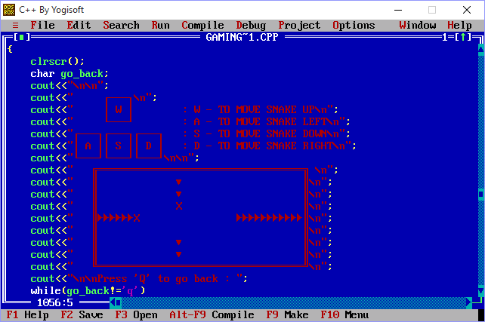

cout<<"\n\nPress 'Q' to go back : ";

while(go_back!='q')

{

go_back=getch();

if(go_back=='q'||go_back=='Q')

{

cout<<go_back;

go_back='q';

}

}//end of while

}//end of instruction

void snake()

{

clrscr();

int load_x,load_y,x,y,i;

cout<<" ________ _ ______ __ _________\n";

cout<<" ( ______| |\\ | ____ \\ / / | _______| \n";

cout<<" \\ \\ | |\\ \\ | | | | / / | | \n";

cout<<" \\ \\ | | \\ \\ | |____| |/ / | |-------|\n";

cout<<" \\ \\| | \\ \\ | |____| |\\ \\ | -------| \n";

cout<<" _______\\ \\| \\ \\| | | | \\ \\ | |_______ \n";

cout<<" (__________) \\__| |_| \\_\\ | ________| \n";

cout<<"\n\n\n\n";

cout<<" . . \n";

cout<<" . . \n";

cout<<" . . \n";

cout<<" \\ \\ / / \n";

cout<<" \\ \\ / / \n";

cout<<" \\ \\/ / \n";

cout<<" \\ / \n";

cout<<" \\ / \n";

cout<<" \\ / | \n";

cout<<" \\ \\ | | \n";

cout<<" | | | | \n";

cout<<" | | | | | | \n";

cout<<" | | | | | | \n";

gotoxy(35,12);

cout<<"LOADING";

for(load_x=42,load_y=12,x=25,y=10,i=1;i<=27;i++,x++)

{

delay(100);

gotoxy(x,y);

cout<<(char)222;//or219

if(i==1)

{

gotoxy(load_x,load_y);

cout<<".";

load_x+=1;

}

if(i%6==0)

{

gotoxy(42,12);

clreol();

load_x=42;

}

if(i%2==0)

{

gotoxy(load_x,load_y);

cout<<".";

load_x+=1;

}

delay(200);

}//end of for loop

snake_menu();

getch();

}

///////////////////////////////////////////////////////////////////////////////////////////////

///////////////////////////////////////// USER ENTRY FORM /////////////////////////////////////

///////////////////////////////////////////////////////////////////////////////////////////////

class player

{

public:

struct n

{

char fname[11];

char lname[11];

}name;

char username[16];

char password[17];

char gender;

char mobile[11];

player()

{

strcpy(name.fname,"0000000000");

strcpy(name.lname,"0000000000");

strcpy(username,"000000000000000");

strcpy(password,"0000000000000000");

gender='0';

strcpy(mobile,"0000000000");

}

};

long s=sizeof(player);

void sign_in();

void sign_up();

void sign_up()

{

clrscr();

int i,j;

//log in

for(i=72;i<81;i++)

{ gotoxy(i,1);cout<<char(205); }

gotoxy(72,1);cout<<char(201);gotoxy(73,2);cout<<"SIGN IN";gotoxy(80,1);cout<<char(187);//left+right top

for(i=72;i<81;i++)

{ gotoxy(i,3);cout<<char(205); }

gotoxy(72,3);cout<<char(200);gotoxy(80,3);cout<<char(188);//left+right bottom

gotoxy(72,2);cout<<char(186);gotoxy(80,2);cout<<char(186);//lft most+right most center vertical line

//first name

gotoxy(1,3);cout<<" Name:";

for(i=1;i<15;i++)

{ gotoxy(i,4);cout<<char(196); }

gotoxy(1,4);cout<<char(218);gotoxy(2,5);cout<<"First";gotoxy(14,4);cout<<char(191);

for(i=1;i<14;i++)

{ gotoxy(i,6);cout<<char(196); }

gotoxy(1,6);cout<<char(192);gotoxy(14,6);cout<<char(217);

gotoxy(1,5);cout<<char(179);gotoxy(14,5);cout<<char(179);

//last name

for(i=20;i<34;i++)

{ gotoxy(i,4);cout<<char(196); }

gotoxy(20,4);cout<<char(218);gotoxy(21,5);cout<<"Last";gotoxy(33,4);cout<<char(191);

for(i=20;i<33;i++)

{ gotoxy(i,6);cout<<char(196); }

gotoxy(20,6);cout<<char(192);gotoxy(33,6);cout<<char(217);

gotoxy(20,5);cout<<char(179);gotoxy(33,5);cout<<char(179);

gotoxy(1,7);cout<<" Choose your username:";

for(i=1;i<35;i++)

{ gotoxy(i,8);cout<<char(196); }

gotoxy(1,8);cout<<char(218);gotoxy(12,9);cout<<"eg. username@gmail.com";gotoxy(34,8);cout<<char(191);

for(i=1;i<34;i++)

{ gotoxy(i,10);cout<<char(196); }

gotoxy(1,10);cout<<char(192);gotoxy(34,10);cout<<char(217);

gotoxy(1,9);cout<<char(179);gotoxy(34,9);cout<<char(179)<<" Maximum 15 characters";

//create password 1,13

gotoxy(1,11);cout<<" Create password:";

for(i=1;i<21;i++)

{ gotoxy(i,12);cout<<char(196); }

gotoxy(1,12);cout<<char(218);gotoxy(20,12);cout<<char(191);

for(i=1;i<21;i++)

{ gotoxy(i,14);cout<<char(196); }

gotoxy(1,14);cout<<char(192);gotoxy(20,14);cout<<char(217);

gotoxy(1,13);cout<<char(179);gotoxy(20,13);cout<<char(179)<<" Maximum 16 & minimum 5

characters";

//gender

gotoxy(1,15);cout<<" Gender:";

for(i=1;i<6;i++)

{ gotoxy(i,16);cout<<char(196); }

gotoxy(1,16);cout<<char(218);gotoxy(5,16);cout<<char(191);

for(i=1;i<6;i++)

{ gotoxy(i,18);cout<<char(196); }

gotoxy(1,18);cout<<char(192);gotoxy(5,18);cout<<char(217);

gotoxy(1,17);cout<<char(179);gotoxy(5,17);cout<<char(179)<<" (M/F)";

//mobile phone number

gotoxy(1,19);cout<<" Mobile phone:";

for(i=1;i<20;i++)

{ gotoxy(i,20);cout<<char(196); }

gotoxy(1,20);cout<<char(218);gotoxy(2,21);cout<<"+91 ";gotoxy(19,20);cout<<char(191);

for(i=1;i<20;i++)

{ gotoxy(i,22);cout<<char(196); }

gotoxy(1,22);cout<<char(192);gotoxy(19,22);cout<<char(217);

gotoxy(1,21);cout<<char(179);gotoxy(19,21);cout<<char(179);

//create account

for(i=30;i<48;i++)

{ gotoxy(i,23);cout<<char(240); }

gotoxy(30,23);cout<<char(240);gotoxy(31,24);cout<<(char)240<<"CREATE

ACCOUNT"<<(char)240;gotoxy(47,23);cout<<char(240);

for(i=30;i<48;i++)

{ gotoxy(i,25);cout<<char(240); }

gotoxy(30,25);cout<<char(240);gotoxy(47,25);cout<<char(240);

gotoxy(30,24);cout<<char(240);gotoxy(47,24);cout<<char(240);

player temp,obj;

int x=2,y=5;

char ch;

while(1)

{

gotoxy(x,y);

if(x==77&&y==2)//sign in

{

i=0;

while(1)

{

if(kbhit())

{

ch=getch();

if(ch=='\t')

{

x=2;y=5;

break;

}

if(ch==13)

{

sign_in();

}

}//end of kbhit()

}//end of inner while

}//if ends

gotoxy(x,y);

if(x==2&&y==5)//fname

{

i=0;

while(1)

{

if(kbhit())

{

ch=getch();

if(ch==13||ch=='\t')

{

if(temp.name.fname[2]!='0')//name not to be short

{ x=21;y=5;

if(i!=0)

temp.name.fname[i]='\0';

}

break;

}

if(ch=='\b')

{

if(i>0)

{

temp.name.fname[i]='0';

i--;

cout<<"\b \b";

}

}

else

{

if(i<10)

{

if(i==0)

{

clreol();gotoxy(14,5);cout<<char(179); gotoxy(20,5);

cout<<char(179)<<"Last";gotoxy(33,5);cout<<char(179);

gotoxy(3,5);

}

temp.name.fname[i]=ch;

i++;

cout<<ch;

}

}

}//end of kbhit()

}//end of inner while

if(i!=0)

temp.name.fname[i]='\0';

}//if ends

gotoxy(x,y);

if(x==21&&y==5)//lname

{

i=0;

while(1)

{

if(kbhit())

{

ch=getch();

if(ch==13||ch=='\t')

{

if(temp.name.lname[2]!='0')//name not to be short

{ x=2;y=9;

if(i!=0)

temp.name.lname[i]='\0';

}

break;

}

if(ch=='\b')

{

if(i>0)

{

temp.name.lname[i]='0';

i--;

cout<<"\b \b";

}

}

else

{

if(i<10)

{

if(i==0)

{ clreol();gotoxy(33,5);cout<<char(179);gotoxy(22,5); }

temp.name.lname[i]=ch;

i++;

cout<<ch;

}

}

}//end of kbhit()

}//end of inner while

if(i!=0)

temp.name.lname[i]='\0';

}//if ends

gotoxy(x,y);

if(x==2&&y==9)//username

{

i=0;

while(1)

{

if(kbhit())

{

ch=getch();

if(ch==13||ch=='\t')

{

if(temp.username[2]!='0')//username not to be short

{ x=2;y=13;

if(i!=0)

{

cout<<"@gmail.com";

temp.username[i]='\0';

}

fstream f;

f.open("player.txt",ios::in|ios::binary);

while(f.read((char*)&obj,s))

{

if(strcmp(obj.username,temp.username)==0)

{

gotoxy(3,9);clreol();gotoxy(34,9);cout<<char(179);

gotoxy(35,9);cout<<" Username already exists!!!!!!!";

x=2;y=9;break;

}

else

{

clreol();gotoxy(34,9);cout<<char(179);gotoxy(35,9);

cout<<" Maximum 15 characters";

}

}

f.close();

}

break;

}

if(ch=='\b')

{

if(i>0)

{

temp.username[i]='0';

i--;

cout<<"\b \b";

}

}

else

{

if(i<15)

{

if(i==0)

{ clreol();gotoxy(34,9);cout<<char(179);gotoxy(35,9);

cout<<" Maximum 15 characters";gotoxy(3,9);

}

temp.username[i]=ch;

i++;

cout<<ch;

}

}

}//end of kbhit()

}//end of inner while

if(i!=0)

temp.username[i]='\0';

}//if ends

gotoxy(x,y);

if(x==2&&y==13)//password

{

i=0;

while(1)

{

if(kbhit())

{

ch=getch();

if(ch==13||ch=='\t')

{

if(temp.password[5]!='0')//password not to be short

{ x=3;y=17;

if(i!=0)

temp.password[i]='\0';

}

break;

}

if(ch=='\b')

{

if(i>0)

{

temp.password[i]='0';

i--;

cout<<"\b \b";

}

}

else

{

if(i<16)

{

if(i==0)

{ clreol();gotoxy(20,13);cout<<char(179)<<" Maximum 16 & minimum 5

character";;gotoxy(3,13);

}

temp.password[i]=ch;

cout<<"*";

i++;

}

}

}//end of kbhit()

}//end of inner while

if(i!=0)

temp.password[i]='\0';

}//if ends

gotoxy(x,y);

if(x==3&&y==17)//gender

{

i=0;

while(ch!='m'||ch!='f'||ch!='M'||ch!='F')

{

if(kbhit())

{

ch=getch();

if(ch==13||ch=='\t')

{

if(temp.gender!='0')

{ x=6;y=21; }

break;

}

if(ch=='\b')

{

if(i>0)

{

temp.gender='0';

i--;

cout<<"\b \b";

}

}

if( (ch=='m'||ch=='f'||ch=='M'||ch=='F')&&(i<1) )

{

if(ch<65||ch>90)

ch-=32;

cout<<ch;

temp.gender=ch;

i++;

}

}//end of kbhit()

}//end of inner while

}//if ends

gotoxy(x,y);

if(x==6&&y==21)//mobile no.

{

i=0;

while(1)

{

if(kbhit())

{

ch=getch();

if(ch==13||ch=='\t')

{

if(temp.mobile[9]!='0')//name not to be short

{ x=38;y=24;

if(i!=0)

temp.mobile[i]='\0';

}

break;

}

if(ch=='\b')

{

if(i>0)

{

temp.mobile[i]='0';

i--;

cout<<"\b \b";

}

}

if(ch<=58&&ch>=48&&i<10)

{

if(i==0)

{ clreol();gotoxy(19,21);cout<<char(179);gotoxy(7,21); }

temp.mobile[i]=ch;

i++;

cout<<ch;

}

}//end of kbhit()

}//end of inner while

if(i!=0)

temp.mobile[i]='\0';

}//if ends

gotoxy(x,y);

if(x==38&&y==24)//create account

{

while(1)

{

if(kbhit())

{

ch=getch();

if(ch=='\t')

{

x=77;y=2;

break;

}

if(ch==13)

{

fstream f;

f.open("player.txt",ios::out|ios::in|ios::binary);

if(f.fail())

{

clrscr();

cerr<<"\nFile got corrupt!!!";

getch();

exit(1);

}

f.seekp(0,ios::end);

f.write((char*)&temp,s);

f.close();

sign_in();

}

}//end of kbhit()

}//end of inner while

}//if ends

}//end of outer while

}//end of sign_up()

void sign_in()

{

clrscr();

int i;

player temp,obj;

//log in

for(i=70;i<81;i++)

{ gotoxy(i,1);cout<<char(205); }

gotoxy(70,1);cout<<char(201);gotoxy(72,2);cout<<"SIGN UP";

gotoxy(80,1);cout<<char(187);//left+right top

for(i=70;i<81;i++)

{ gotoxy(i,3);cout<<char(205); }

gotoxy(70,3);cout<<char(200);gotoxy(80,3);cout<<char(188);//left+right bottom

gotoxy(70,2);cout<<char(186);gotoxy(80,2);cout<<char(186);//lft most+right most center

//vertical line

//first name

gotoxy(25,9);cout<<" USERNAME:";

for(i=25;i<50;i++)

{ gotoxy(i,10);cout<<char(196); }

gotoxy(25,10);cout<<char(218);gotoxy(26,11);cout<<"username";gotoxy(50,10);cout<<char(191);

for(i=25;i<50;i++)

{ gotoxy(i,12);cout<<char(196); }

gotoxy(25,12);cout<<char(192);gotoxy(50,12);cout<<char(217);

gotoxy(25,11);cout<<char(179);gotoxy(50,11);cout<<char(179);

gotoxy(25,13);cout<<" PASSWORD:";

for(i=25;i<50;i++)

{ gotoxy(i,14);cout<<char(196); }

gotoxy(25,14);cout<<char(218);gotoxy(27,15);gotoxy(50,14);cout<<char(191);

for(i=25;i<50;i++)

{ gotoxy(i,16);cout<<char(196); }

gotoxy(25,16);cout<<char(192);gotoxy(50,16);cout<<char(217);

gotoxy(25,15);cout<<char(179);gotoxy(50,15);cout<<char(179);

for(i=33;i<43;i++)

{ gotoxy(i,18);cout<<char(205); }

gotoxy(33,18);cout<<char(201);gotoxy(35,19);cout<<"SIGN IN";

gotoxy(43,18);cout<<char(187); //left+right top

for(i=33;i<43;i++)

{ gotoxy(i,20);cout<<char(205); }

gotoxy(33,20);cout<<char(200);gotoxy(43,20);cout<<char(188);//left+right bottom

gotoxy(33,19);cout<<char(186);gotoxy(43,19);cout<<char(186);//lft most+right most center

//vertical line

int x=76,y=2;

char ch;

while(1!=0)

{

gotoxy(x,y);

if(x==76&&y==2)//sign up

{

while(1)

{

if(kbhit())

{

ch=getch();

if(ch=='\t')

{

x=26;y=11;

break;

}

if(ch==13)

{

//f.close();

sign_up();

}

}//end of kbhit()

}//end of inner while

}//if ends

gotoxy(x,y);

if(x==26&&y==11)//username

{

i=0;

while(1)

{

if(kbhit())

{

ch=getch();

if(ch==13||ch=='\t')

{

if(temp.username[2]!='0')//username not to be short

{ x=27;y=15;

if(i!=0)

{

cout<<"@gmail.com";

temp.username[i]='\0';

}

}

break;

}

if(ch=='\b')

{

if(i>0)

{

temp.username[i]='0';

i--;

cout<<"\b \b";

}

}

else

{

if(i<15)

{

if(i==0)

{ clreol();gotoxy(25,11);cout<<char(179);gotoxy(50,11);

cout<<char(179);gotoxy(27,11);

}

temp.username[i]=ch;

i++;

cout<<ch;

}//end of inner if

}

}//end of kbhit()

}//end of inner while

if(i!=0)

temp.username[i]='\0';

}//if ends

gotoxy(x,y);

if(x==27&&y==15)//password

{

i=0;

while(1)

{

if(kbhit())

{

ch=getch();

if(ch==13||ch=='\t')

{

if(temp.password[5]!='0')//password not to be short

{ x=39;y=19;

if(i!=0)

temp.password[i]='\0';

}

break;

}

if(ch=='\b')

{

if(i>0)

{

temp.password[i]='0';

i--;

cout<<"\b \b";

}

}

else

{

if(i<16)

{

if(i==0)

{ clreol();gotoxy(25,15);cout<<char(179);gotoxy(50,15);

cout<<char(179);gotoxy(27,15);

}

temp.password[i]=ch;

cout<<"*";

i++;

}

}

}//end of kbhit()

}//end of inner while

if(i!=0)

temp.password[i]='\0';

}//if ends

gotoxy(x,y);

if(x==39&&y==19)//sign in

{

while(1)

{

if(kbhit())

{

ch=getch();

if(ch=='\t')

{

x=76;y=2;

break;

}

if(ch==13)

{

fstream f;

f.open("player.txt",ios::out|ios::in|ios::binary);

if(f.fail())

{

clrscr();

cerr<<"\nFile got corrupt!!!";

getch();

exit(1);

}

while(f.read((char*)&obj,s))

{

if((strcmp(temp.username,obj.username)==0)&&(strcmp(temp.password,

obj.password)==0))

{

f.close();

game_choose();

}

}

f.close();

}

}//end of kbhit()

}//end of inner while

}//if ends

}//end of outer while

}

void main()

{

sign_in();

}

OUTPUTS

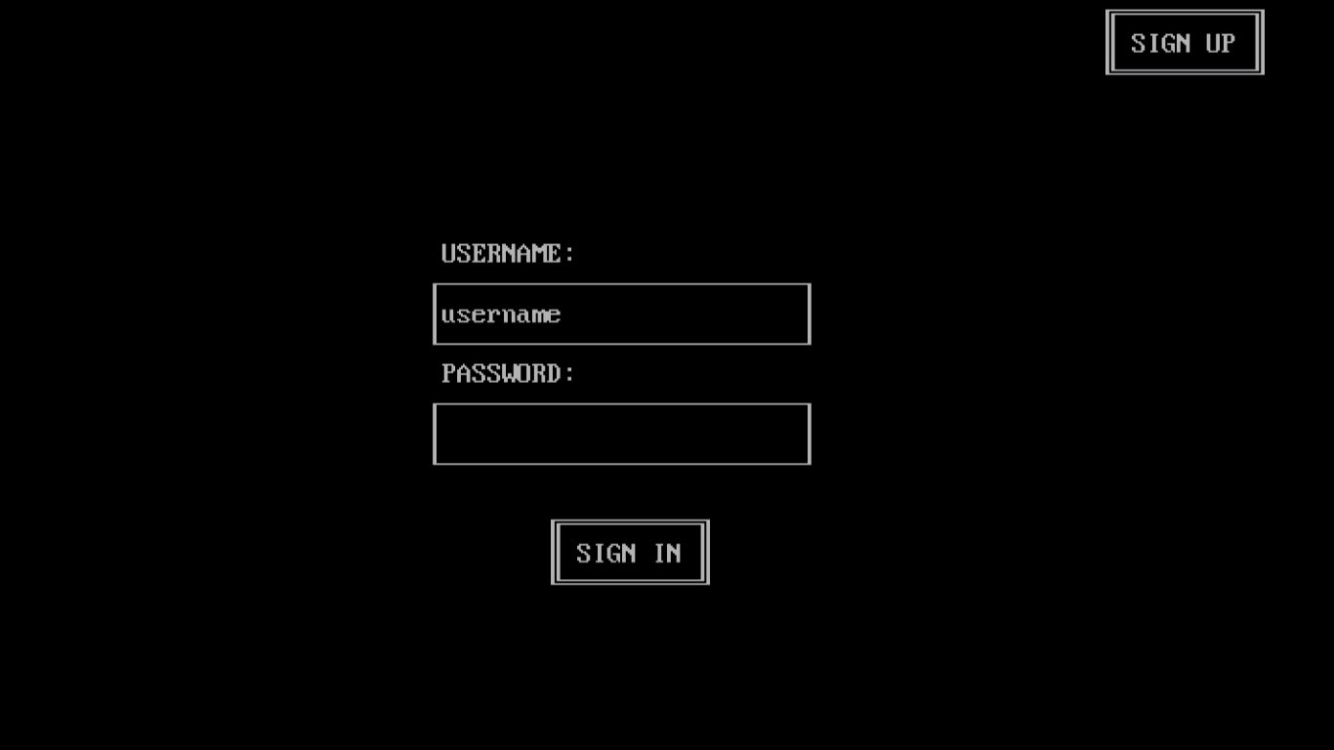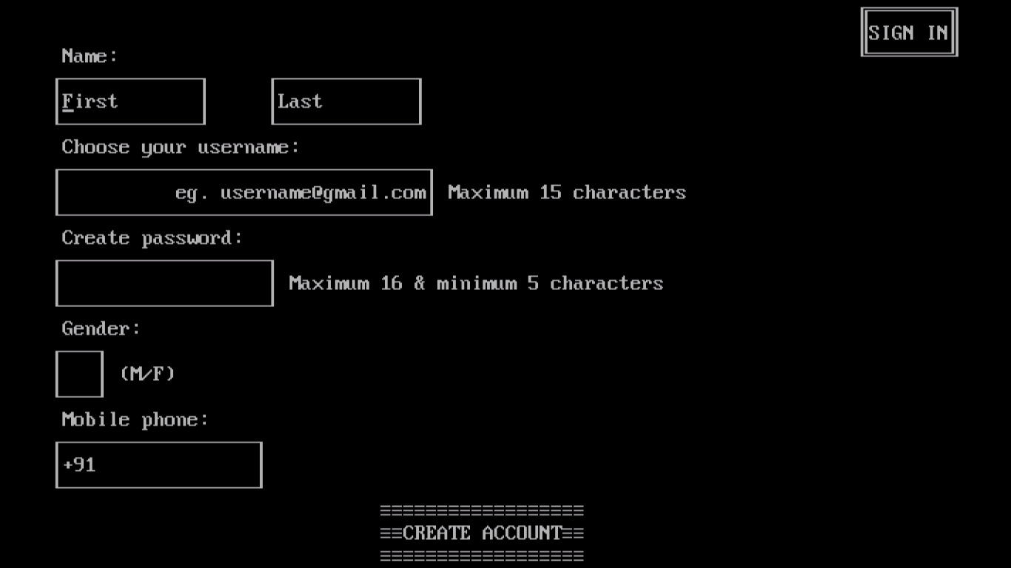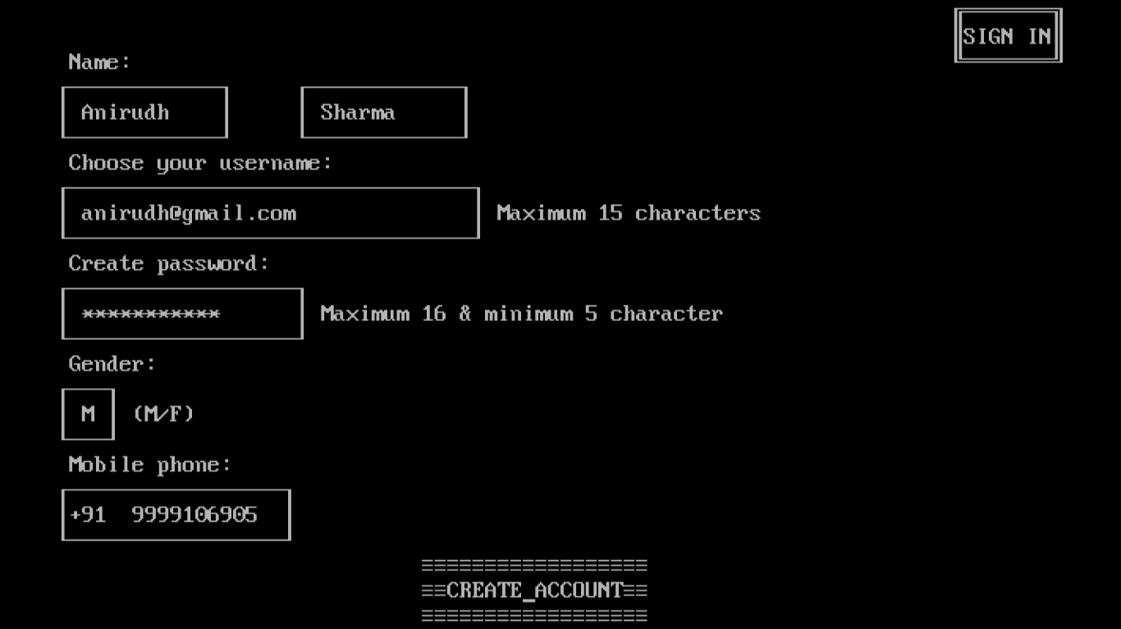

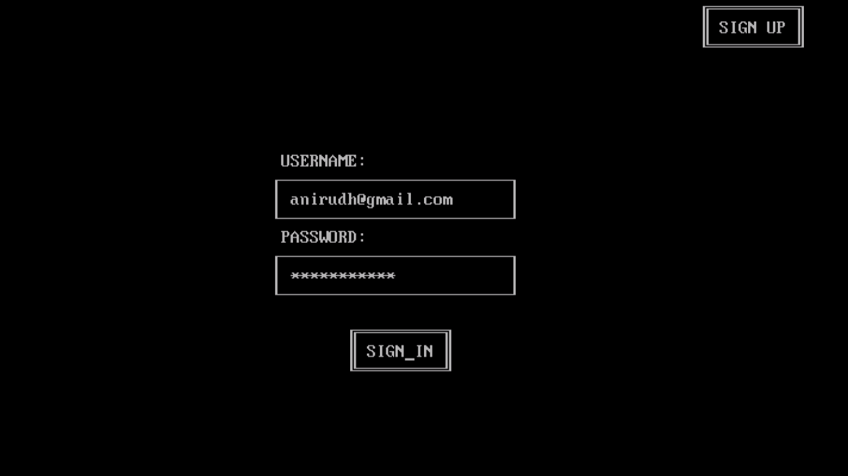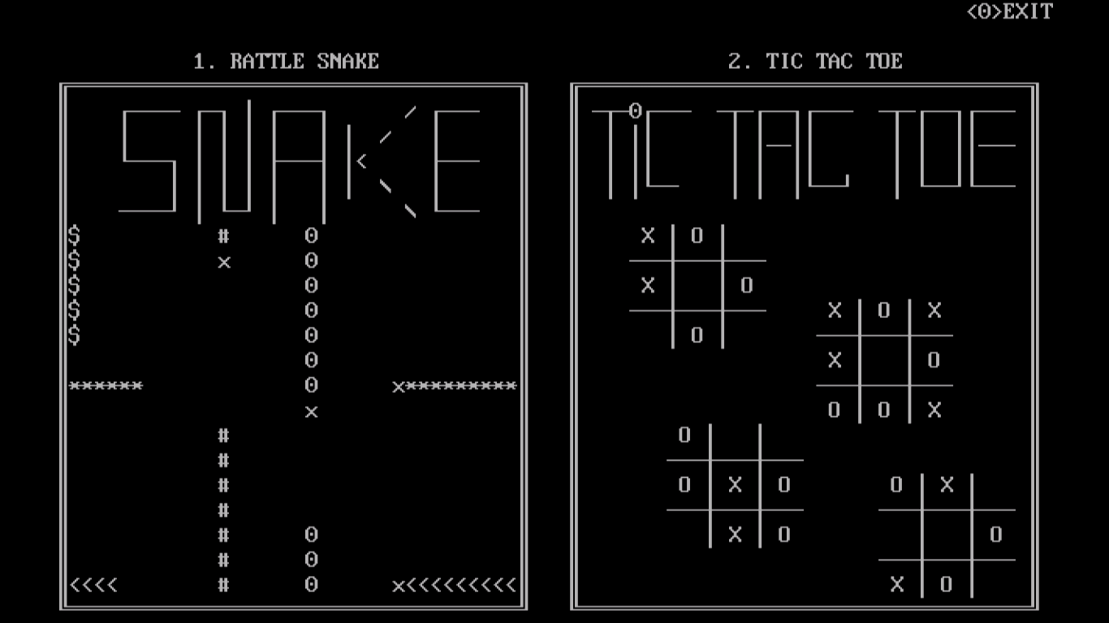

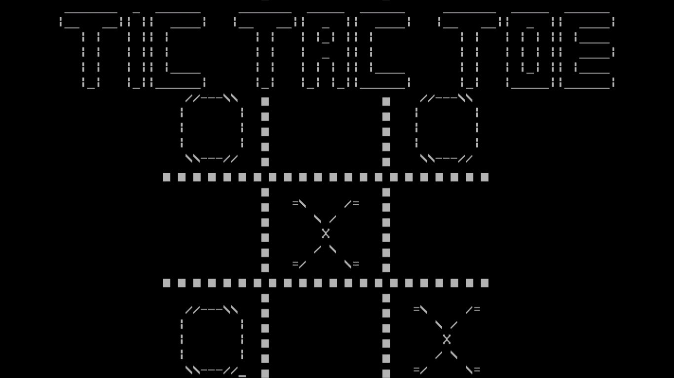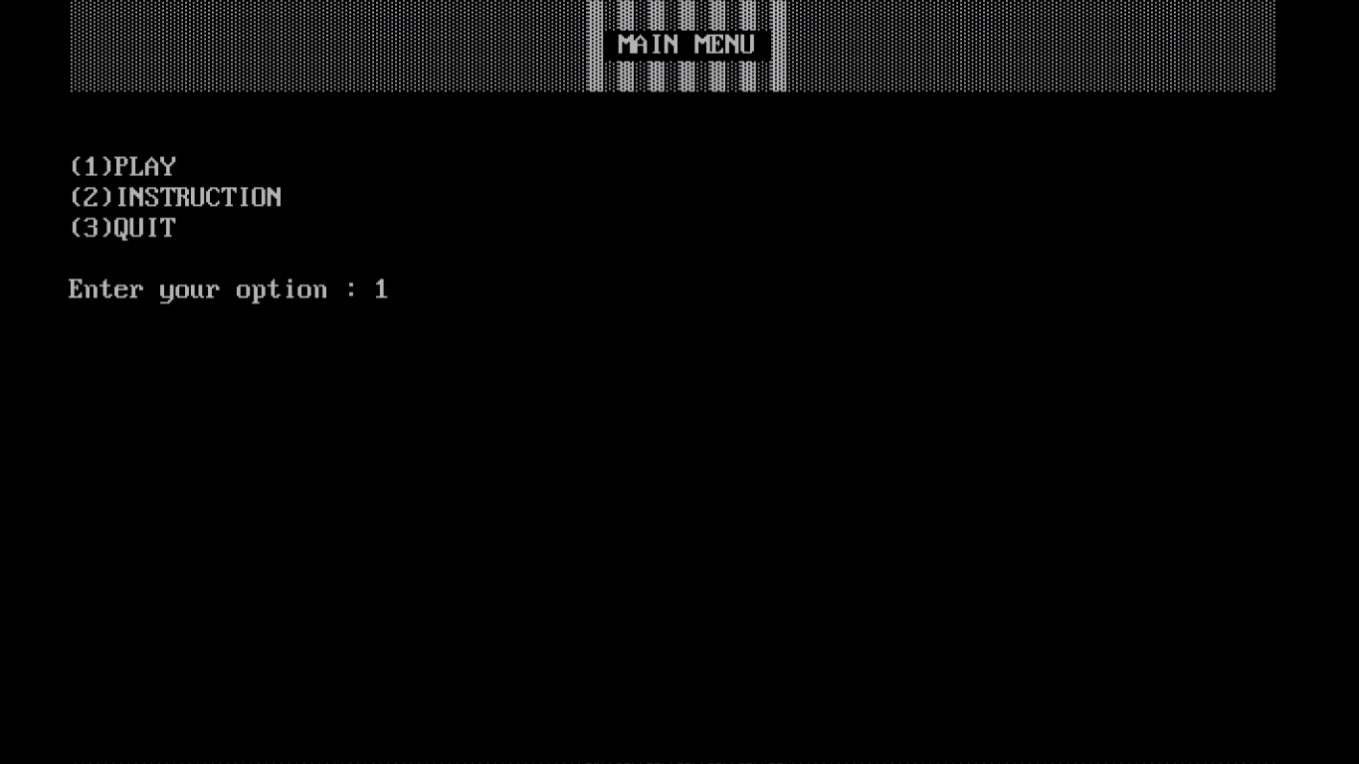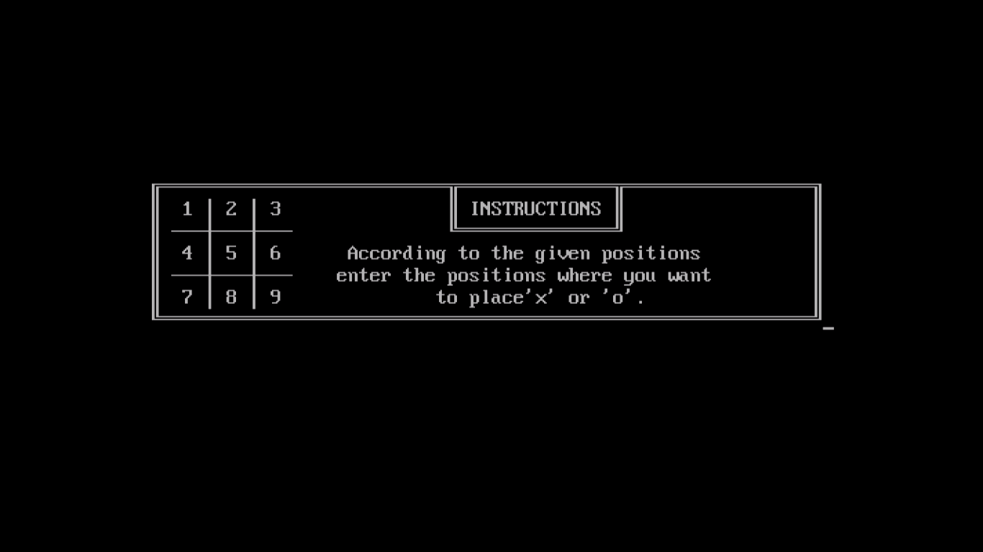

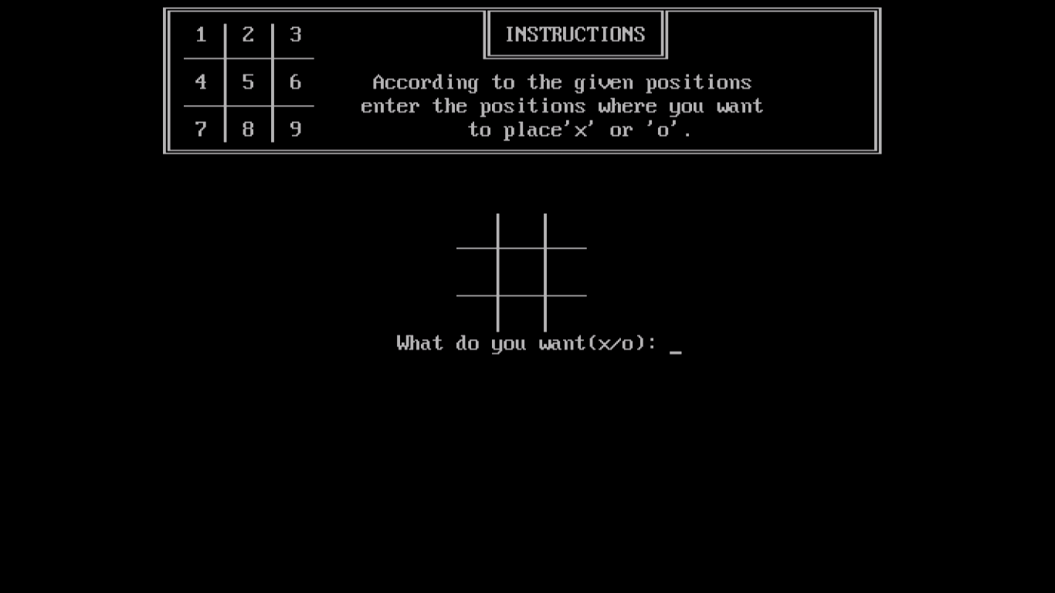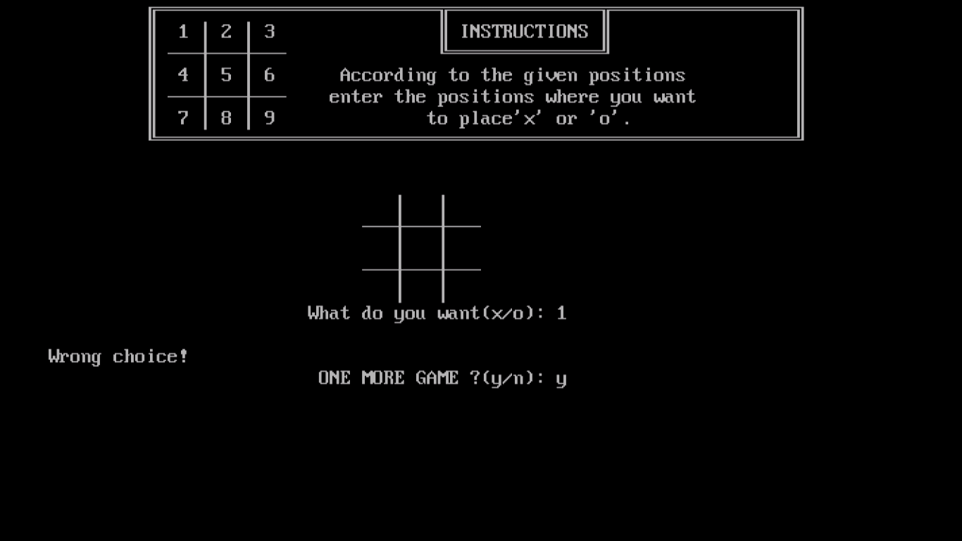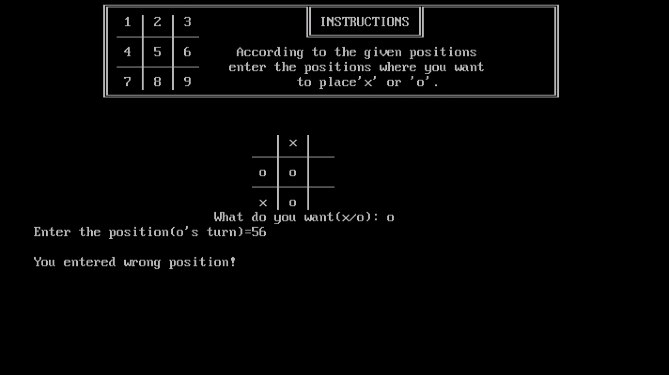

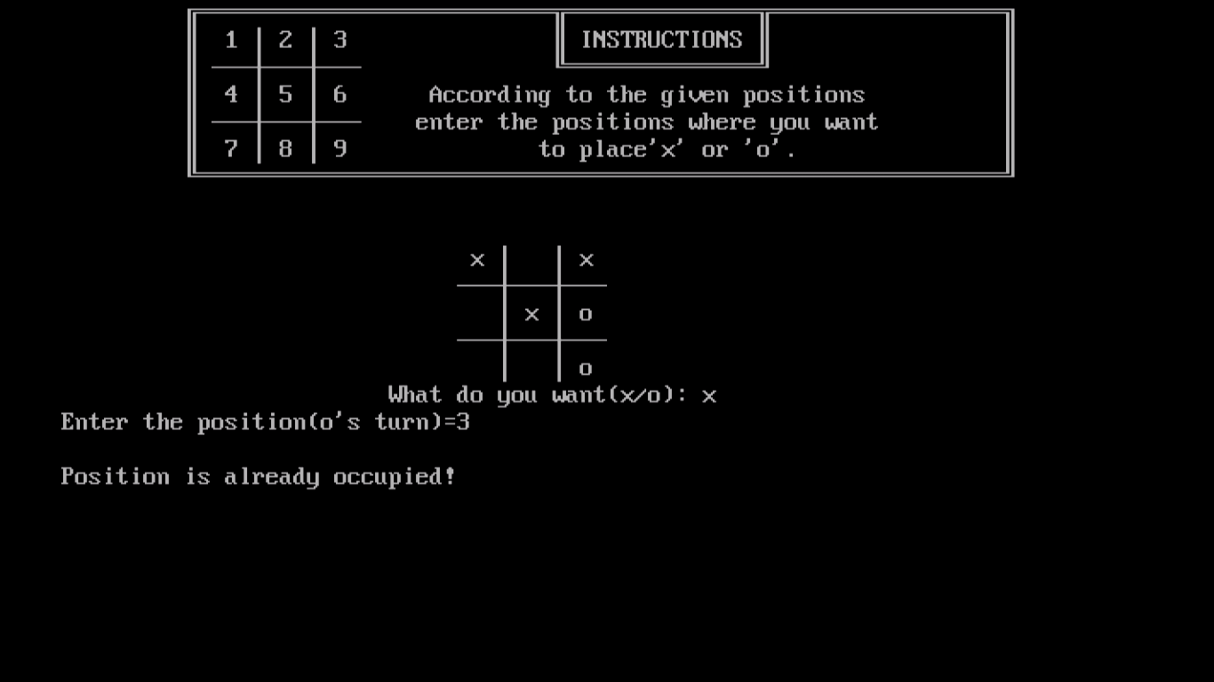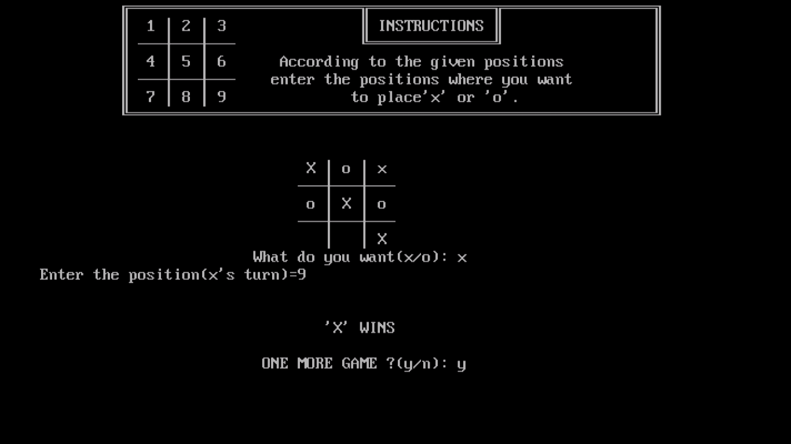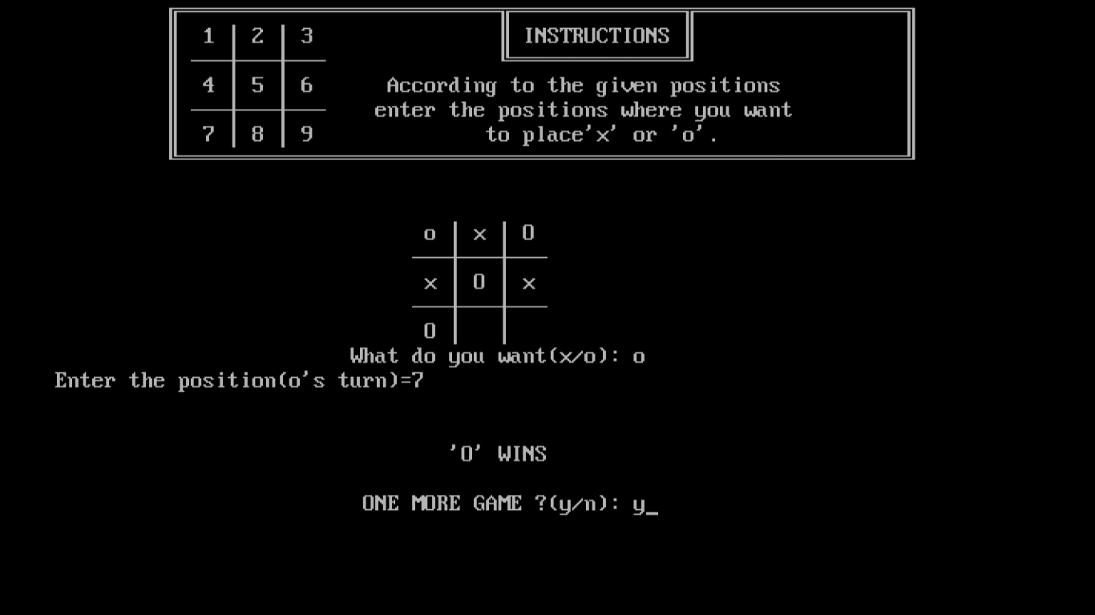





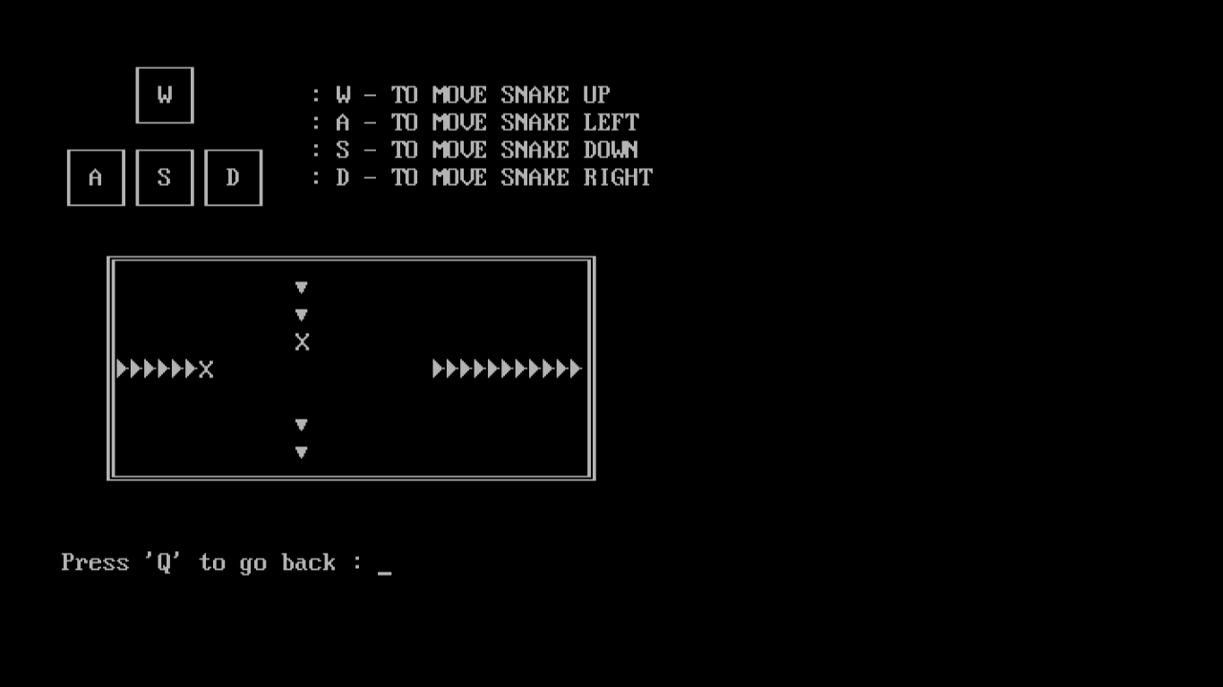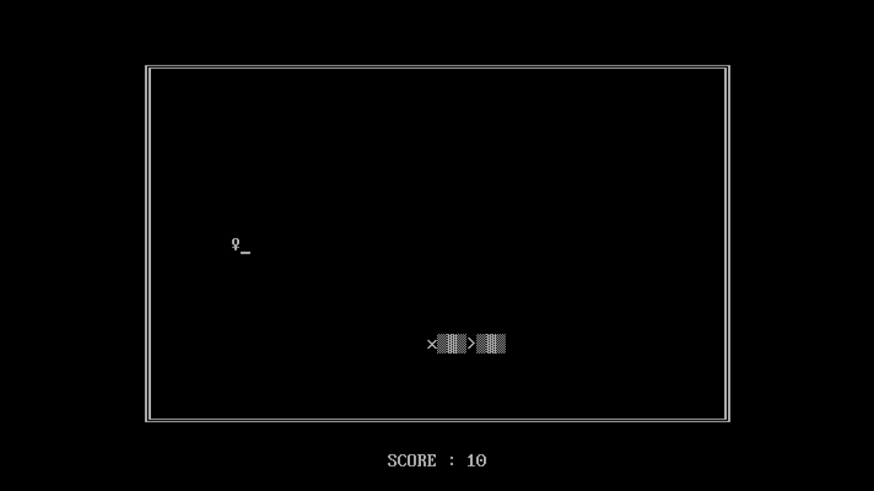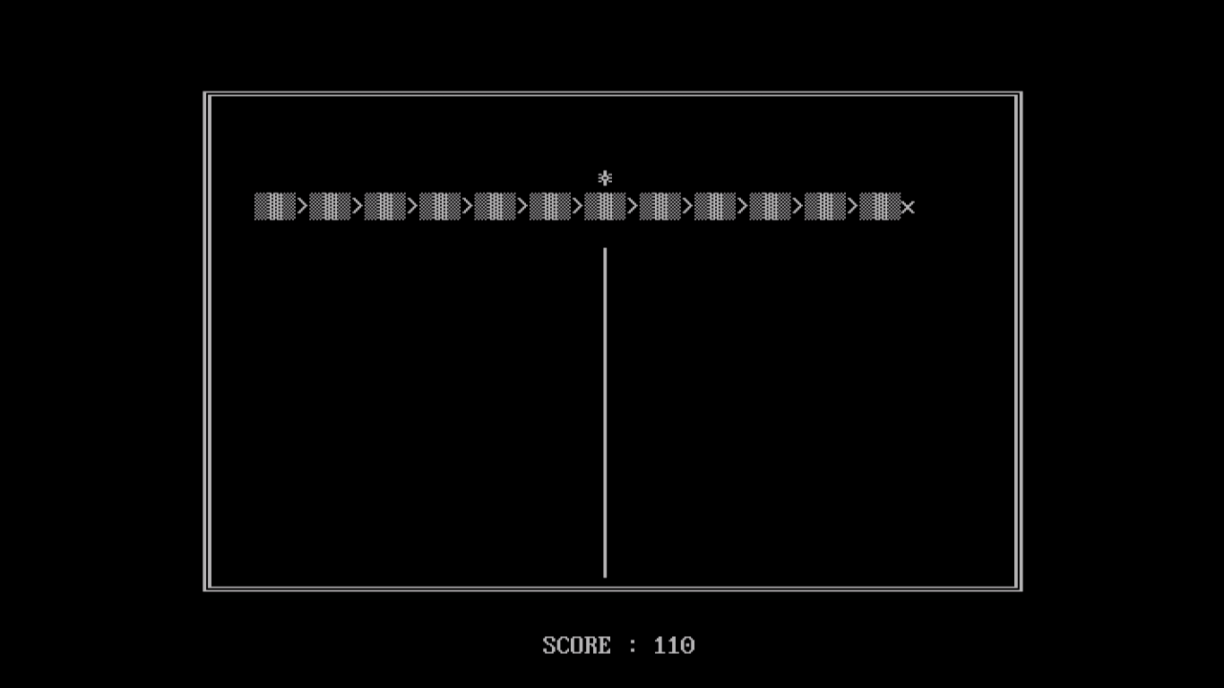

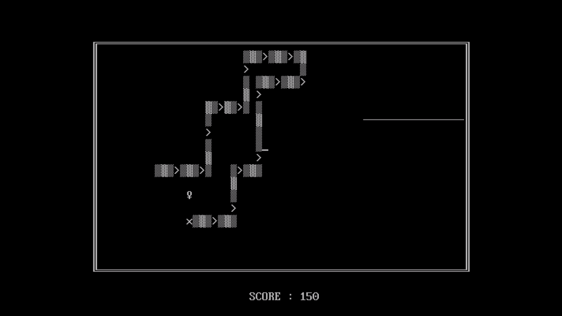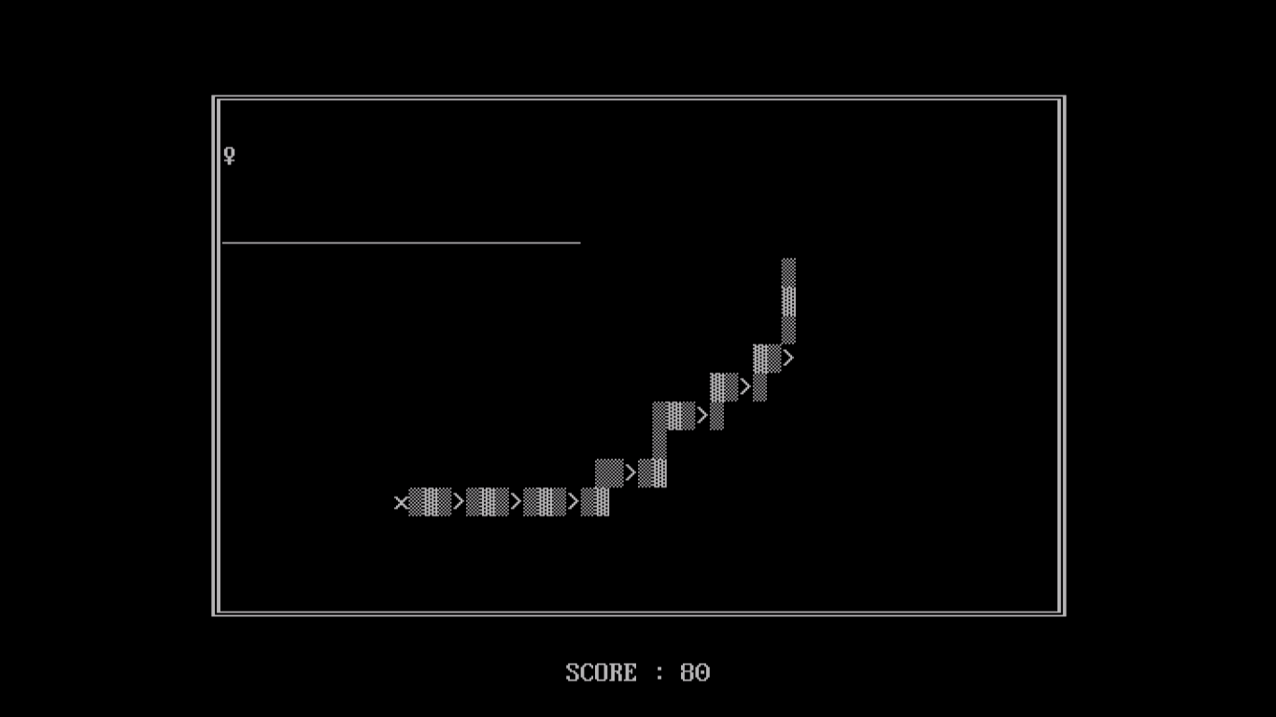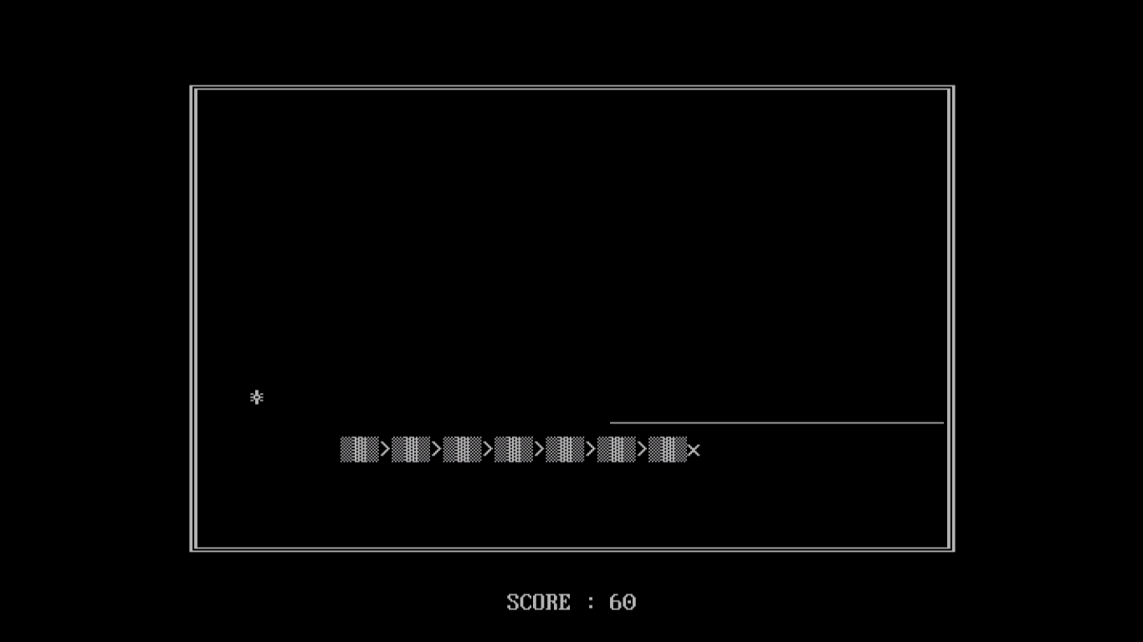

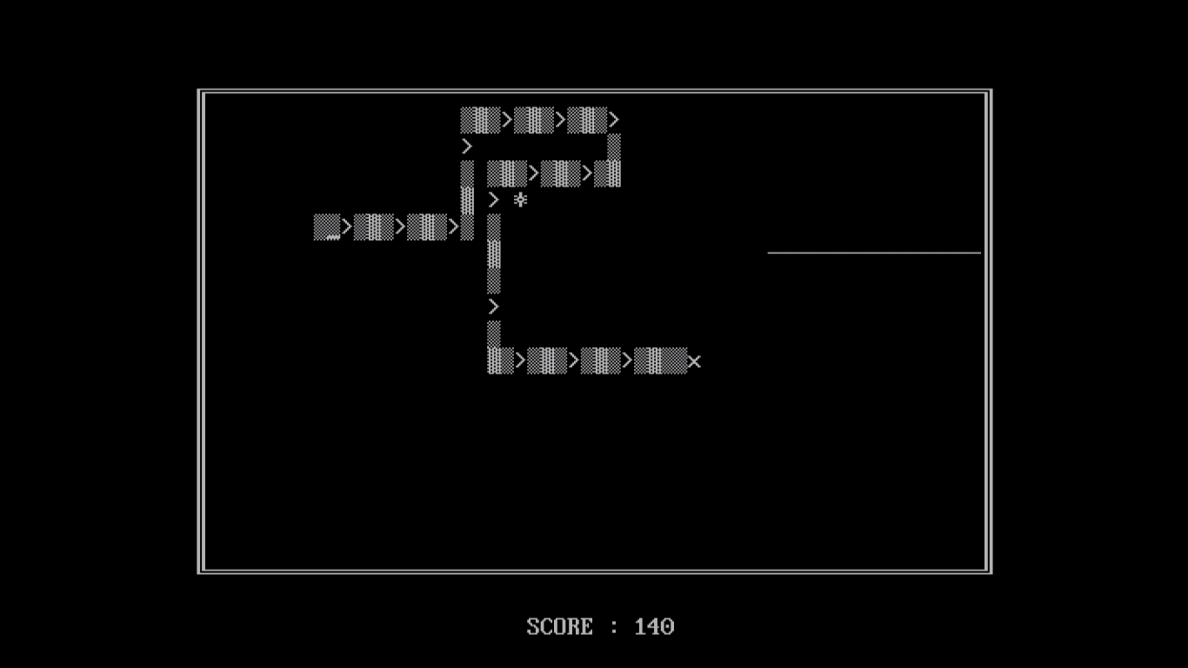

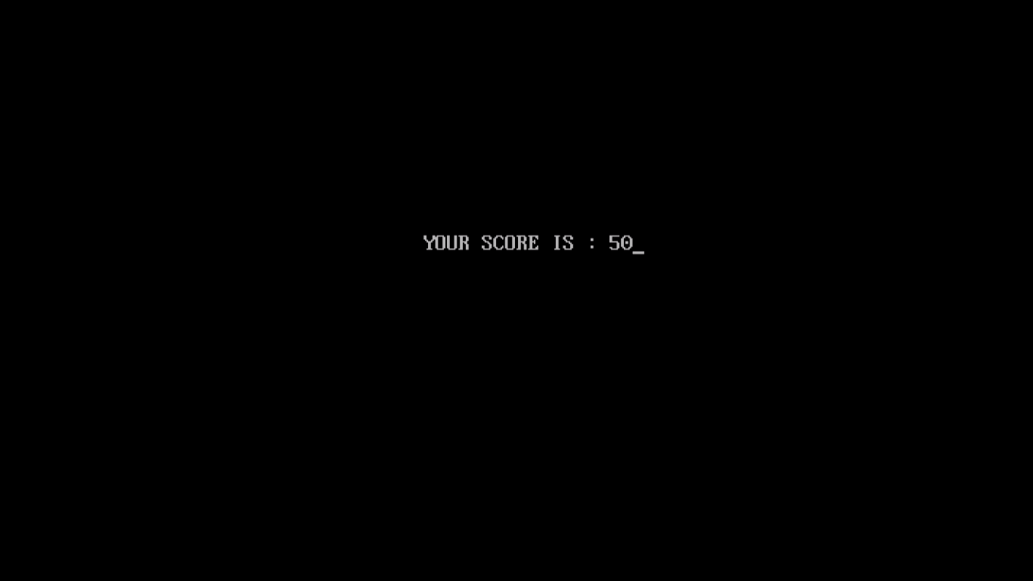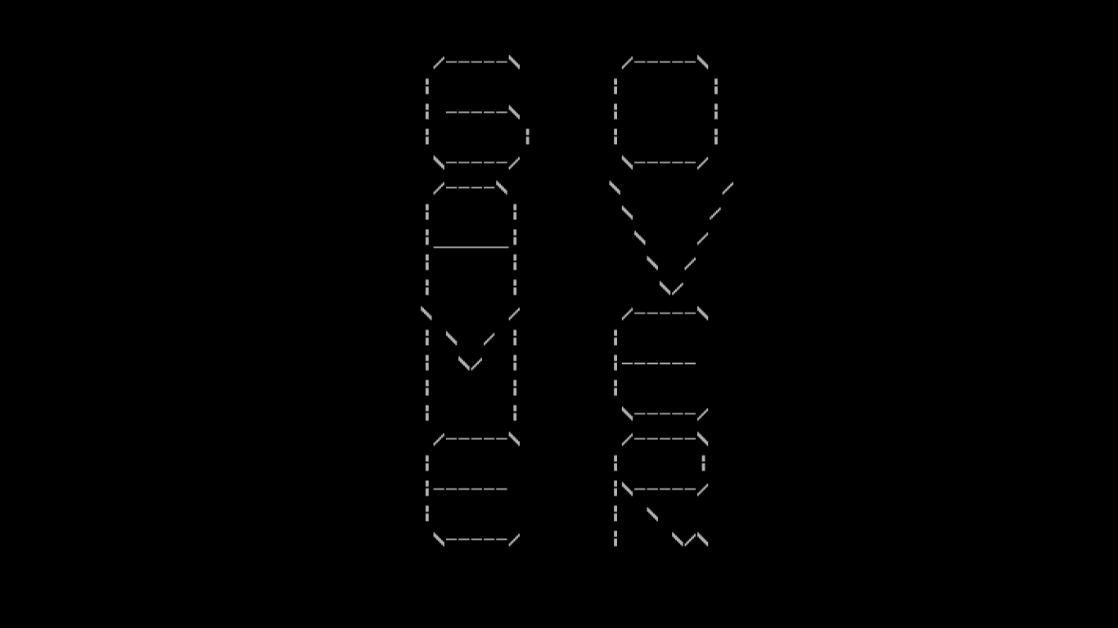

BIBLIOGRAPHY